# .Net Core website containerisation (Build Process)

## Aim

The aim of this guide is to take .Net Core website and

1. Add docker support
2. Create an ADO build which will
   * Build our application
   * Publish our application
   * Create a Docker Image
   * Push a Docker image to our iPipeline container registry
3. Pull the image and run it locally.

## Detail

1. Add docker support
   1. To add docker support to an existing .Net Core website in Visual Studio 2019 you can right click the project in Solution Explorer, click add and then click Docker Support.
   2. This will create a Dockerfile in the root of the website.
   3. Example of a dockerfile for a website called HelloDocker

FROM mcr.microsoft.com/dotnet/core/aspnet:3.1-buster-slim AS base

WORKDIR /app

EXPOSE 80

EXPOSE 443

FROM mcr.microsoft.com/dotnet/core/sdk:3.1-buster AS build

WORKDIR /src

COPY ["HelloDocker4/HelloDocker.csproj", "HelloDocker/"]

RUN dotnet restore "HelloDocker/HelloDocker.csproj"

COPY . .

WORKDIR "/src/HelloDocker"

RUN dotnet build "HelloDocker.csproj" -c Release -o /app/build

FROM build AS publish

RUN dotnet publish "HelloDocker.csproj" -c Release -o /app/publish

FROM base AS final

WORKDIR /app

COPY --from=publish /app/publish .

ENTRYPOINT ["dotnet", "HelloDocker.dll"]

* 1. Check-in the Dockerfile.

1. Create an ADO build
   1. Create an empty build definition
   2. Add the ‘.Net Core SDK Installer’ step, targeting the same .Net Core version as used in your website.
   3. Add the ‘Build an image’ step.

Setting the following -

* + 1. Docker registry service connection
    2. The location of the dockerfile
    3. Set use default bind context to false
    4. Set Build context to $(System.DefaultWorkingDirectory)
    5. Set image name based on target (example sandbox/$(Build.Repository.Name):$(Build.BuildId))

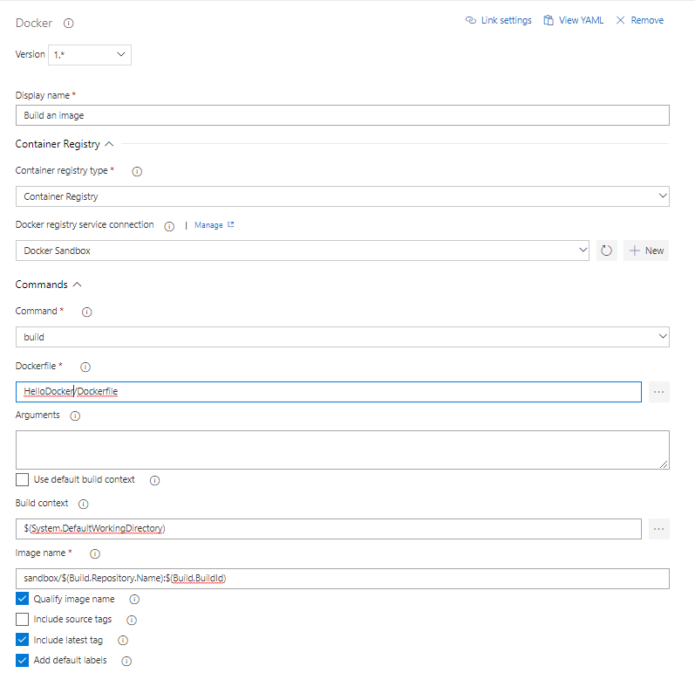

* 1. Add the ‘Push an image’ step
  2. Setting the following –
     1. Docker registry service connection.
     2. Image name (to get both the build specific tag and latest tag you should not use the buildid in the format).

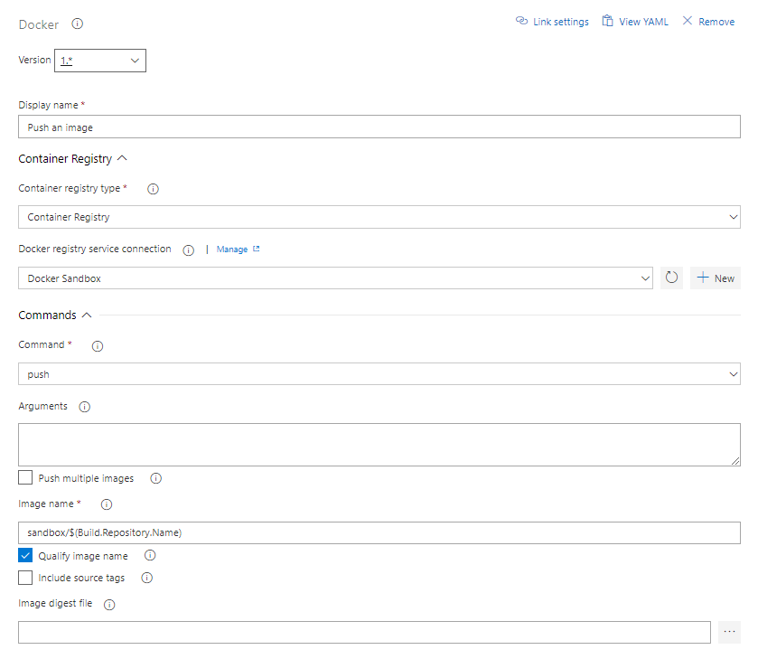

Build view –

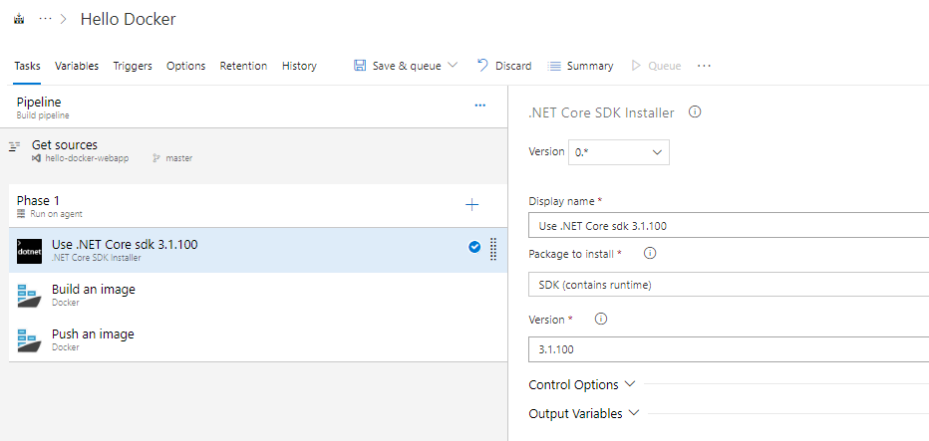

Now run the build and make it succeed!

1. Pull the image and run it locally

Example command (image does not exist so don’t try and run!) - docker run -it --rm -p 5004:80 --name hello-docker library.ipipeline.uk.com/sandbox/library/hello-docker:31443

Then navigate to http://localhost:5004